



AI Ethics in a Smart City Traffic Management System

Disclaimer: The content is curated from online/offline resources and used for educational purpose only

Case Study

# Case Study: AI Ethics in a Smart City Traffic Management System

## Introduction

Smart cities are evolving with the integration of artificial intelligence into infrastructure and services. One critical application of AI in smart cities is traffic management through the monitoring, prediction, and control of real-time traffic flow. These systems promise to reduce congestion, create public safety, and ensure efficient transportation. However, deploying such high profile and public AI technologies raises numerous ethical issues. The case study focuses on how AI ethics were implemented in a smart city traffic management system, with emphasis on transparency, fairness, accountability, and privacy.

## Background

City X is an urbanizing metropolitan area with a population size exceeding 5 million. Suffice it to say that it suffered from a critical traffic congestion problem. The city's transportation department decided to adopt intelligent traffic management, which would use AI along with machine learning techniques for predicting congestion and synchronizing signal timings. The key goals here are reductions in travel times, emission reductions, and the improvement of safety. It became apparent to the city's officials that they needed to address AI-related issues of bias in the decision-making process, data privacy, and systems accountability. So the project had to have the cutting-edge AI technology but AI ethics, as well.

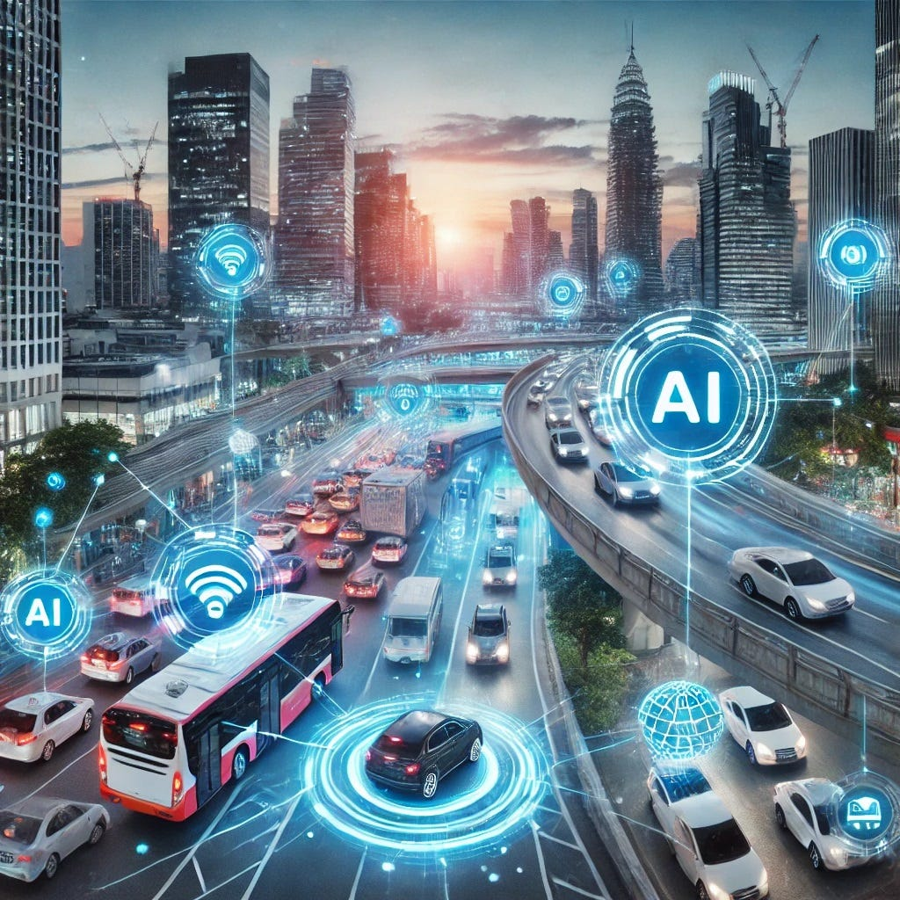

Source: https://medium.com/@aitechdaily/smart-cities-how-ai-is-revolutionizing-urban-traffic-management-abefbdb020aa

## Challenges

1. **Data Privacy and Surveillance Concerns**

The system needed access to large volumes of data originating from various sources, which could be from traffic cameras, mobile applications, GPS data, and social media feeds. Such issues relating to the level of surveillance and use, sharing, and protection of citizen's data were raised by citizens. There had to be the challenge of gathering the right amount of data for an efficient operation alongside individual privacy security.

### Bias and Fairness

This results in AI systems being trained on historical data, and this can encode biases already present in a system. Without proper care, the traffic management system might end up favoring some routes or regions over others, thus continuing inequality in access to transportation. This challenge was to ensure that the system would treat all regions and demographics equally and that all those areas that have been marginalized in a city's previous planning schemes were represented.

### Transparency and Accountability

The citizens and officials needed to understand how the AI system was making the decisions. In case the transparency of the system is also lacking, then the AI-based system can create easy mistrust about the system. The problem related to accountability regarding errors or failures in the system-cases, such as possible traffic accidents or increased congestion-was also to be dealt with.

## Ethical Implementation Framework

To such a challenge, City X established an AI Ethics Framework that would depict how the smart traffic management system should be deployed and operate.

Key pillars of the framework include the following:

### Transparency and Explainability

The deployable AI algorithms and models adopted were, as much as possible, transparent and explainable for better decision-making. All this was meant to be transparent regarding why traffic lights would be tweaked, why spot congestion was anticipated in certain regions, and how all these decisions were made. City X's transportation department collaborated with AI developers so that the reasoning behind it could therefore be understood by both experts and laypersons. System updates and performance metrics were regularly put into public reports.

### Bias Mitigation and Fairness

The system was built on a large set of different data that is representative of all the regions and areas demographically across the city. The establishment of a fairness auditing mechanism means that third-party experts reviewed the system's process periodically to detect and resolve biased behaviors. More than that, the AI was programmed not to reinforce historical traffic patterns which, in turn, were against the interests of parts of the community. This meant that the underrepresented regions would equally share the responsibility for congestion management.

### Data Privacy and Protection

The smart city traffic system was designed with a privacy-first approach. The smart city traffic system anonymized data so that it did not identify people. Only the most minimal amount of information was collected for the system to be optimized. Subsequent practices were implemented in regards to enforcing data governance in the city, where data so collected was kept safe and was not transferred to third parties without direct consent. Control over their data was placed in the hands of the citizens, along with opt-in and opt-out options for consent-based participation in the gathering of data using mobile apps, and other interfaces.

### Accountability and Redress Mechanisms

Transparency was ensured by defining a clear and well-defined governance structure. A clear and well-defined chain of accountability was in place so that responsibility was traced back from the developers of AI to the city officials in case of an error in the system. An independent ethics review board was constituted to oversee the system's operation and to investigate any ethical issues and complaints from citizens. This redress mechanism provided citizens with an avenue to express their grievances or report any situation in which they felt the system had led to unfair outcomes.

## Outcomes

The roll out of AI ethics in the smart traffic management system of City X elicited the following positive impacts:

### Public Trust Improved

Concentrating more on the transparency of its system and the involvement of citizens, it built trust in the AI system within the city. Public reports, data policies, and fairness audits ensured that citizens had access to their information usage and how the system benefits the whole of the city equally.

### Traffic Flow and Safety Improved

The AI system decreased traffic congestion by 20% during the first year of its existence. Traffic accidents in highly congested areas went down by 15% for the simple reason that the system could predict and mitigate high-risk traffic conditions. Real-time adjustments to traffic signals improved response times by 10% for emergency vehicles.

### Balanced Access to Transportation

The bias mitigation strategies also ensured that no area won at another's expense. Previously experiencing a long commute time, the low-income neighborhood saw a 12% decrease in traffic delay time, thus enhancing access to services and economic opportunities.

### Good Data Practices

This system was totally designed with privacy first; otherwise, it could end up appealing for the public eye. Six months after its launch, surveys manifested that 78% of the respondents were confident that their data was being handled responsibly.

## Lessons Learned

### Continuous Observing

AI ethics is not the one-and-done type of implementation. City X realized that it must continuously observe and audit the system to guarantee fairness and transparency. Indeed, constant evolution could bring forth new biases and privacy issues that would call for updates in the ethical framework over time.

### Collaboration Among Stakeholders

The close collaboration between AI developers, city officials, ethicists, and citizens would have much influenced the success of the project. Early engagement of diversified perspectives helps to identify potential pitfalls in terms of ethics, and more robust solutions are implemented.

### Citizen Education and Engagement

An education by the public on how the AI systems operate and informing the general public on decisions being made helped make the system more palatable to the citizens. The fact that citizens tend to accept and embrace this system was when they appreciated its utility, as well as the ethical security measures.

## Conclusion

In the case of City X's intelligent traffic management, AI ethics were decisive factors in the deployment and consideration of public infrastructure projects. Proactivity on these issues related to privacy, fairness, and accountability proved to make AI considerably good and appealing for the deployment of a highly effective system, one that would improve flow and safety without undermining public trust. This case demonstrates its example for other cities as a city that leverages AI with ethical standards for the digital age.